Summer 2021
Halal and vegetarian options are provided at all meals.
( Breakfast, lunch and tea )
Week 1 | 3/5/21 | 24/5/21 | 14/6/21 | 5/7/21 | 26/7/21 | 16/8/21
Week 2 | 10/5/21 | 31/5/21 | 21/6/21 | 12/7/21 | 2/8/21 | 23/8/21
Week 3 | 17/5/21 | 7/6/21 | 28/6/21 | 19/7/21 | 9/8/21 | 30/8/21

 |  | Monday | Tuesday | Wednesday | Thursday | Friday
Week 1 | Lunch | Homemade Fish cakes, new potatoes, peas sweetcorn and parsley sauce | Chicken Fajitas,tex mex rice, chopped salad and dip | Butternut Squash, and Spinach Pasta Bake, salad and garlic bread | Homemade Meat and Potato Pie with carrots, broccoli, mashed potatoes and gravy | Homemade Margarita Pizza beans and chips
 | Pudding | Strawberry Mousse | Homemade Cookies | Vanilla Yoghurt and Strawberry Sauce | Strawberry Cheesecake | Ice cream
 | Tea | Veggi Sausage and beans on toast  Flapjack | Pizza and homemade Pasta Salad  Asst Yoghurts | Jacket Potatoes, cheese, beans and salad  Cornflake Buns | Veggie Cheeseburgers and salad  Iced Cupcakes | Vegetable Fingers and potato waffles  Chocolate cream squares
Week 2 | Lunch | Tangy Tomato Spaghetti and cheese, garlic bread, chopped salad | Homemade Cheese and Onion Quiche, new potatoes sweetcorn, peas and cheese sauce | Homemade Chicken Curry, Fried rice, naan bread and dip | Homemade Shepherd’s Pie, New potatoes, broccoli and gravy | Fishfingers, chips and beans
 | Pudding | Chocolate Mousse | Zesty Orange Cake | Homemade Cookies | Strawberry Sponge and custard | Jelly and Delight
 | Tea | Sandwiches, veggie sticks, lentil chips, yoghurt dip  Chocolate chip cookies | Veggie Ravioli on toast  Birds Nest buns | Potato shells filled with cheese and beans, with coleslaw and salad  Lemon cake | Homemade Veggie Cheese Pasta and Garlic Bread  Krispie Buns | Veggie Burgers in a bun with salad and dip  Strawberry creamcake
Week 3 | Lunch | Homemade pizza, herby potatoes, spaghetti hoops | Barbecue Chicken, Chopped Salad and vegetable rice | Tomato and roast pepper Fusilli with Cheese Sauce,garlicbread | Lamb Burritos, Salad, buttered new potatoes and yoghurt dip | Cheese and Roast vegetable pie, Chips and Beans
 | Pudding | Fruity Jelly and Mousse | Chocolate Sponge and Chocolate Sauce | Ice Cream | Lemon Drizzle Cake | Vanilla Yoghurt and Raspberry Sauce
 | Tea | Veggie Sausage  Pasta Bake and Garlic Bread  Asst Yoghurts | Beans on Granary Toast  Homemade Shortbread | Samosas, pakoras, salad and raita  Victoria Cake | Pizza Toasties and beans  Cornflake Buns | Sandwiches, babybels, veggie sticks, lentil crisps  Assorted Cupcakes

Breakfast

Breakfast is available each day, consisting of:
- Choice of cereals or porridge
- Range of breads
- Fresh fruit
- Milk
Menu information
- All main meals are accompanied with seasonal vegetables or 5 individual salad items, and either potato, rice, pasta, chapattis, or naan bread. In addition, bread is available each day.
- All meat and poultry used is fresh and locally sourced.
- All our fish, vegetarian & cheese dishes are suitable for Muslims.
- We do not use any preservatives or additives that are unsuitable for children.
- All menus are subject to availability and may change without notice.

From our Food Policy…
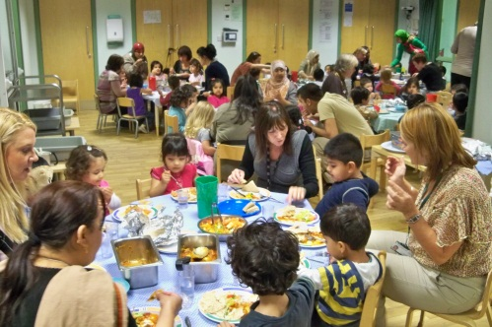
We serve only healthy food and drink and all meals will be prepared by our own staff, with reference to national, nutritional guidelines.
- Mealtimes are seen as a learning experience and all opportunities for counting, problem solving and communicating are exploited. Older children set the tables and act as servers.
- Mealtimes are unhurried and relaxed with children being allowed ample time to eat.
- Babies are introduced to an open or free-flowing cup at 6 months and are discouraged from using a bottle from this time.
- Babies and children are encouraged to develop their physical feeding skills by feeding themselves using their fingers as early as possible, moving to spoons, spoon and fork and then knife and fork as their control develops
Please talk to a member of staff for more information.

